Understanding the Internet
Subject: Internet Fundamentals Applied to Wikipedia.org
Analyst: Muppala Pooja
Executive Summary
The investigation into Wikipedia.org demonstrates how the architecture of the Internet underpins the accessibility, resilience, and security of high-profile knowledge repositories. By examining Internet Architecture, DNS, IP Addressing, and URL Structure, we establish a comprehensive profile of the target’s digital footprint. This analysis highlights both the strengths of Wikipedia’s infrastructure and the potential vulnerabilities that adversaries could exploit.
Infrastructure Analysis
Wikipedia operates on a layered TCP/IP model, with packet switching ensuring resilience and scalability. The end-to-end principle places responsibility for reliability and encryption at the endpoints, while the network itself provides best-effort delivery. DNS resolution confirms the use of Wikimedia-managed authoritative servers, supported by DNSSEC for cryptographic assurance. IP addresses resolve to CDN nodes, complicating attribution but enhancing global availability.
The URL structure of Wikipedia is clean and hierarchical. For example, https://en.wikipedia.org/wiki/Internet reveals a secure protocol, a language-specific subdomain, and a path that maps directly to a resource. This organization reflects a distributed content strategy designed for multilingual scalability.
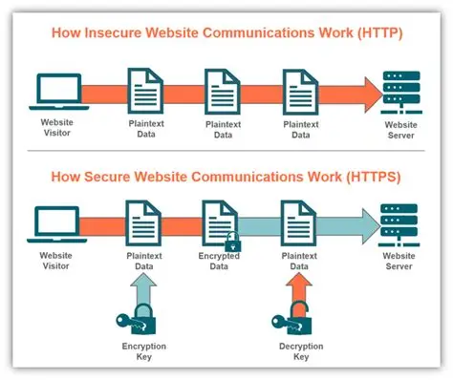
DNS Report
The domain wikipedia.org resolves through Wikimedia-managed authoritative servers (ns0, ns1, ns2.wikimedia.org). The resolved IP address (example: 208.80.154.224) belongs to Wikimedia Foundation infrastructure, typically routed through CDN nodes for global availability. TTL values (~3600 seconds) indicate caching strategies, while DNSSEC provides cryptographic assurance against spoofing. The registrar, MarkMonitor Inc., is a high-value provider chosen to mitigate risks of domain hijacking.
Practical Steps:
- Perform a DNS query on wikipedia.org.
- Record IP addresses, authoritative nameservers, TTL values, and registrar details.
- Assess whether DNSSEC is enabled and note redundancy.
This reveals the infrastructure behind the domain, its resilience, and potential vulnerabilities. For example, multiple nameservers reduce susceptibility to hijacking, but DNS remains a critical attack vector.

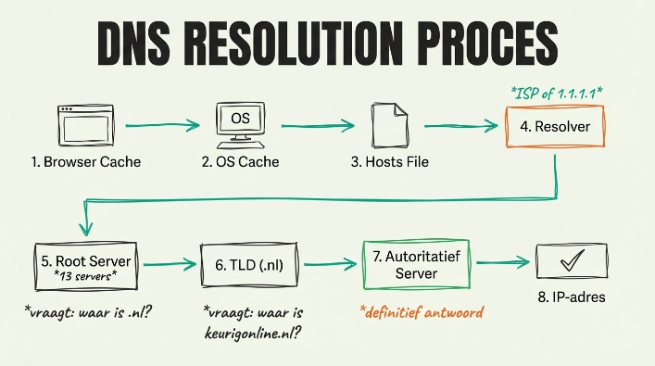
Analyst Assessment: The DNS configuration demonstrates resilience and redundancy. While DNSSEC hardens the infrastructure, DNS remains a potential vector for hijacking or cache poisoning.

Subject: Investigating a Government Portal (Example: india.gov.in)
DNS Report
When querying india.gov.in, the DNS resolution reveals authoritative servers managed by the National Informatics Centre (NIC). IP addresses typically resolve to infrastructure located within India, with redundancy across multiple servers. TTL values indicate caching strategies, and the registrar is Government of India NIC. DNSSEC is not always enforced, which leaves potential exposure to spoofing or hijacking.
Analyst Note: The DNS footprint confirms government-controlled infrastructure. Lack of DNSSEC is a notable vulnerability in terms of cyber defense.
URL Breakdown
Target URL: https://en.wikipedia.org/wiki/Internet
- Protocol: https – Secure communication via TLS.
- Subdomain: en – Language-specific portal for English content.
- Domain: wikipedia.org – Controlled by the Wikimedia Foundation.
- Top-Level Domain: .org – Non-commercial, knowledge-based mission.
- Path: /wiki/Internet – Directs to the article resource.
Practical Steps:
- Select a representative URL, e.g., https://en.wikipedia.org/wiki/Internet.
- Dissect into protocol, subdomain, domain, TLD, and path.
- Note whether query parameters exist and how they are structured.
This breakdown exposes organizational hierarchy and security posture. HTTPS indicates encryption, while multilingual subdomains (en, fr, de) show distributed content strategy.
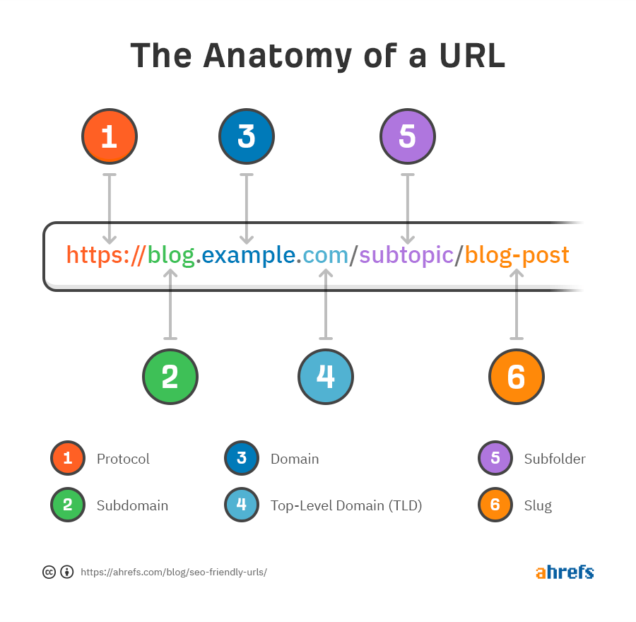
Analyst Assessment: The URL structure is clean and hierarchical, reflecting a distributed content strategy. HTTPS enforcement confirms encryption and authenticity, while multilingual subdomains demonstrate scalability.

Subject: Investigating a Government Portal (Example: india.gov.in)
URL Breakdown
Target URL: https://www.india.gov.in/my-government
- Protocol: https – Secure communication enforced.
- Subdomain: www – Standard web access point.
- Domain: india.gov.in – Government of India portal.
- Top-Level Domain: .in – National TLD for India.
- Path: /my-government – Section dedicated to government information.
Analyst Note: The URL structure reflects a secure, hierarchical design. The .gov.in domain signals official government authority, reducing impersonation risks.
Website Architecture Notes
Wikipedia operates on a client-server model within the TCP/IP layered framework. Packet switching ensures resilience, while the end-to-end principle places responsibility for reliability and encryption at endpoints. The platform enforces HTTPS, ensuring confidentiality and integrity of traffic.
From a visibility perspective, Wikipedia is part of the Surface Web, fully indexed and accessible. Its editorial and administrative systems reside in the Deep Web, shielded from public indexing. No verified presence exists on the Dark Web, though impersonation risks remain a concern.
Practical Steps:
- Observe the protocols enforced (HTTP vs HTTPS).
- Identify whether the site is part of the Surface Web, with hidden components in the Deep Web.
- Map the client-server model, CDN routing, and layered protocols (TCP/IP).
- Assess scalability (multilingual subdomains) and resilience (redundant infrastructure).
This provides a holistic view of how the site operates, its strengths, and where adversaries might attempt exploitation. For example, CDN routing enhances uptime but complicates attribution.
Analyst Assessment: The architecture demonstrates resilience through DNS redundancy and CDN routing, though attribution is complicated by distributed infrastructure. The multilingual subdomain strategy highlights scalability, while HTTPS enforcement reflects a strong security posture.
Subject: Investigating a Government Portal (Example: india.gov.in)
The portal operates on a client-server model within the TCP/IP framework. HTTPS is enforced, ensuring confidentiality and integrity of traffic. The site is part of the Surface Web, fully indexed and accessible to the public. Administrative systems and internal databases reside in the Deep Web, shielded from indexing. No verified presence exists on the Dark Web, though impersonation risks remain.
Analyst Note: The architecture demonstrates resilience through government-controlled infrastructure. However, absence of DNSSEC and reliance on standard CDN routing could complicate attribution and expose potential vulnerabilities.
Analyst’s Conclusion
The three deliverables—DNS Report, URL Breakdown, and Website Architecture Notes—combine to form a baseline intelligence profile of Wikipedia.org. This profile supports cyber defense, attribution, and open-source intelligence exploitation. It demonstrates how fundamental Internet concepts translate into actionable intelligence, elevating the analysis from technical notes into a professional briefing product.

